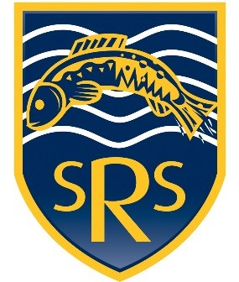
St Raphael’s Catholic Primary School
Operation Encompass Policy

Operation Encompass is a national police and education early intervention safeguarding partnership which supports children and young people who experience Domestic Violence and Abuse and which is in place in every police force in England and Wales. Children were recognised as victims of domestic abuse in their own right in the 2021 Domestic Abuse Act.
Operation Encompass is an integral component in child safeguarding and protection policies and forms part of any such policies. Our DSLs have undertaken training on Operation Encompass.
Operation Encompass means that the police will share information with our school DSLs about all police attended Domestic Abuse incidents which involve any of our children PRIOR to the start of the next school day. This allows the education setting to offer timely support to the child victims.
Support and subsequent actions will include; (dependent on the nature of the Encompass incident)
- Deciding on a tailored response, (age of the child, immediate welfare, current class they are in, any brother/sister within the school, or another school).
- Welfare Check for child/young person.
- Completion of MARAC documentation (if requested by Education Welfare Service).
- Safeguarding meetings (internal to school )
- Ensure key staff are aware to avoid re-traumatisation and are able to respond to any triggers of trauma (e.g Pastoral Manager, Form/Class teacher, noting it is not necessary to share all detail).
- Contact Safeguarding Children in Education Team if needed for signposting/further information advise.
Parent/Carers are fully aware that we are an Operation Encompass school and we ensure that when a new child joins our school the Parent/Carers are informed about Operation Encompass.
When an Operation Encompass email arrives the DSL will acknowledge it’s receipt via return email. The Operation Encompass information is then stored on MyConcern in line with all other confidential Safeguarding and Child Protection information. Within Operation Encompass all records are managed at Child Protection level with the highest level of security and confidentiality, and in full accordance with GDPR.
As a staff we have discussed how we can support our children who are experiencing Domestic Violence and Abuse on a day-to-day basis and particularly following the Operation Encompass notification. We are aware that we must do nothing that puts the child/ren or the non-abusing adult at risk. Operation Encompass will be reported on at each Governor meeting held throughout the year. All information is anonymised for these reports.

Date March 2026 To be reviewed March 2028

