Year Group: Year 1 |  |  |  | Long Term Plan: Summer 2
 | Week 1 | Week 2 | Week 3 | Week 4 | Week 5 | Week 6/7
R.E.  Miracles | Can I recognise that Jesus used his powers to calm the storm? | Can I talk about how it feels to help others? | What is compassion? | Can I explain how Jesus showed his love for people? | Can I recognise that Jesus used his powers to heal the blind man? | What is a miracle?
Literacy | Fact files about Minibeasts | Recounts | Non-Chronological – Leaflet | The Tiny seed  Eric Carle | The Very Hungry Caterpillar | Getting ready for year 2  Goals
Numeracy | Addition and Subtraction  Missing numbers | Money | Position and Direction | Multiplication and Division | Addition and Subtraction – problem solving | Time  Data / block diagrams
Science  Revision / Investigations | Can I classify and identify minibeasts that I find outside? | Can I describe the weather patterns throughout the year? | Which materials sink, which materials float? | What do different seeds look like? | How does a caterpillar become a butterfly? | What makes a great scientist?
Geography  Location Location | Can I use a map of Stalybridge to locate our school on a map? | Can I make a map with a key of the school? | Can I make a map of my route to school? | Can I use compass directions to follow a map? | Can I describe land use around our school? | Can I locate features on a map of school?
Art/D&T  Collage + Textiles | Henri Matisse  The snail | Can I make a collage that represents each season? | Material collage – focus on texture | Can we explore texture of seeds to create a natural collage? | 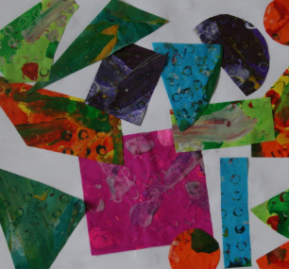  Can I do a collage in the style of Eric Carle? | Can we make a collage of our school grounds??
P.E. | Tameside PE Coaches/Joe Wicks  Athletics
I.C.T | Introduction to Codespark | Can you follow the instructions? | Where will your toy move to? | Where will your toy end up? | Can you program your toy? | Can you spot and find the mistakes?
Music | Tameside Music services  Charanga – Reflect, Rewind and Replay
Big Write | Fact file about Minibeasts | Trip recount (write about a trip out that you have made this week…… a walk bike ride?) | Leaflet – My school | Can I write about the journey of The Tiny Seed  Seasons/months | Retell the story – The Very Hungry Caterpillar  Days of the week | Summer starts here!

