ST RAPAHELS CATHOLIC PRIMARY SCHOOL
ASTHMA POLICY

This policy should be read in conjunction with the Administration of Medicines Policy.

Introduction

This school recognises that asthma is a widespread, serious but controllable condition affecting some children in our school.

This policy is aimed at an audience of parents and staff, seeking to:

- Offer practical advice about the problems which asthmatic children face in school
- Make clear the importance for the school to be well prepared to assist in the management and control of asthma in children
- Underline parental obligations in letting the school know if a child has asthma and the relative seriousness of their child's case.

A Positive Approach

This school:

- Welcomes all pupils with asthma
- Will encourage and help children with asthma to participate fully in all aspects of school life
- Recognises that immediate access to inhalers is essential
- Will do all it can to make sure that the school environment is favourable to children with asthma
- Has a clear understanding of what to do in the event of a child having an asthma attack

Record Keeping

At the beginning of each school year or when a child joins the school, parents/carers are asked if their child has any medical conditions, including asthma, on their contact form.

From this information the school keeps its asthma register, which is available to all school staff.

Parents/carers are also asked to update school if their child’s medicines change, or the dosage/frequency changes during the year.

Asthma medicines

We recognise that access to reliever medication is essential. With this in mind, reliever inhalers are kept in a dedicated box, which accompanies the class when leaving the classroom for a significant period of time

Parents/carers are asked to ensure that the school is provided with two labelled reliever inhalers (and spacer where necessary) in named, resealable bags/boxes. All inhalers must be labelled by the parent/carer with the child’s name and class.

School staff are not required to administer asthma medicines to pupils but all school staff will let pupils take their own asthma medicines when they need to and support the younger pupils in this process.

Reply slips for children to participate in after school activities and residential visits will have a space for parents to record whether or not their child has asthma.

Parents/carers are responsible for ensuring that children always have an inhaler with them in school, for clubs as well as for use during the school day.

The Asthma Attack

The following guidelines will be used if a known asthmatic pupil becomes breathless, wheezy or coughs continually.

- Keep calm. It’s treatable.
- Pupil to sit in a position they find comfortable. Lying down is not necessary.
- Allow pupil to take their usual reliever, giving help, if necessary.
- The reliever inhaler can be repeated after 5 minutes if no improvement.
- If there is no relief of symptoms after second dose send message to ring parents
DO NOT LEAVE THE CHILD ON THEIR OWN
- If parent cannot be contacted, call all emergency contact numbers
- In severe cases, (relief inhaler has no effect at all) call an ambulance to take the pupil to nearest hospital casualty department. Inform parents.
- In the case of a suspected first attack the pupil should be kept calm, an ambulance should be called and parents informed.

PE, games, after school clubs

- Taking part in sports, games and activities is an essential part of school life for all pupils. The school ensures that all adults teaching PE are aware of which children have asthma.
- Pupils with asthma are encouraged to participate fully in all PE lessons whether inside or outdoors.
- Classes take the box of asthma medication with them to PE lessons.
- Children attending after school clubs (e.g. football), will take their reliever inhalers with them and return them to the class box the following day.
- Sports coaches from outside are responsible for ensuring that they are able to deal with an asthma crisis.
- After school clubs run by outside providers must ensure that they are aware of which children in their care have problems with asthma.

Residential stays/school visits

Risk assessments are carried out prior to any visits. Where there is the potential of children coming into contact with animals (e.g. farm visits) parents/carers will be made aware of this is the “visit” letter. They should contact school if any extra precautions need to be taken or, indeed, if they would prefer their child not to take part in the visit.

The school environment

The school has a non-smoking policy throughout the building and grounds both within and outside normal school hours

The school does not keep or use chemicals in science or art lessons that are potential triggers for pupils with asthma.

Conclusion and Summary

Asthma is a very common illness in children and it is important that it is recognised and that it receives optimum treatment.

Modern medical practice is designed to allow a normal quality of life which means taking part in all normal school activities.

Because of the make up of the school day e.g PE, playtime etc staff can become aware of possible asthma symptoms, which may otherwise go unrecognised. Should this arise we will to inform parents/carers in order that they may seek professional advice.

Policy reviewed, May 2017

If your child has an asthma attack

Do you need to call 999 for an ambulance? This page will give you the information you need.
It can be very frightening to see your child having asthma symptoms. And sometimes it can be hard to judge whether to call an ambulance or treat them at home and make an urgent GP appointment. It’s not surprising lots of parents panic in this situation.
But if your child’s having an asthma attack, recognising the signs and taking action quickly could save their life.

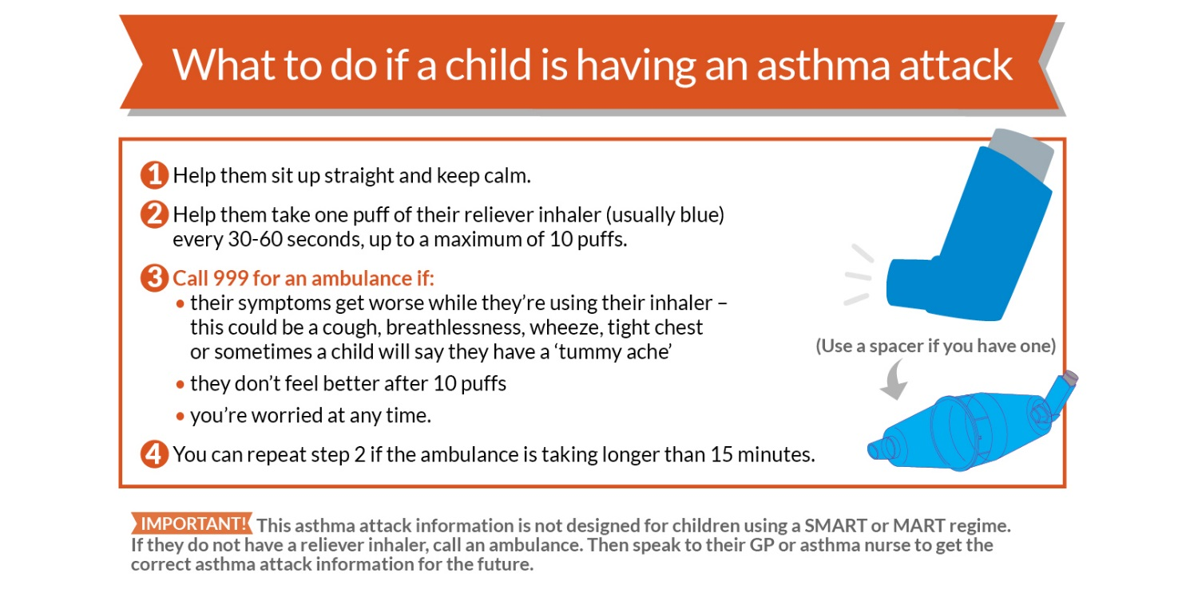

You can spot the signs
We don’t want to scare you, but every 10 seconds, someone in the UK has an asthma attack. Getting treatment urgently could save your child's life, so it’s important for you and anyone else who looks after your child to recognise when they are having an asthma attack.

Your child is having an asthma attack if:
- Their reliever inhaler (usually blue) isn’t helping, and/or
- They can’t talk or walk easily and/or
- They’re breathing hard and fast and/or
- They’re coughing or wheezing a lot and/or
- They may also complain of a tummy ache.

The four simple steps to take now
These steps could save your child’s life so make sure you know them – and share them with other people who look after your child, too.
- Help them to sit up straight and stay calm
- Help them take a puff of their reliever inhaler (usually blue) every 30-60 seconds, up to a maximum of 10 puffs
- Call 999 for an ambulance if:
- their symptoms get worse while they’re using their inhaler
- they don’t feel better after 10 puffs
- you’re worried at any time, even if they haven’t yet taken 10 puffs.
4. While you wait for the ambulance, reassure your child. Repeat step 2 if the ambulance takes longer than 15 minutes.
Always call 999 immediately if you don’t have a reliever inhaler with you.
If you go to A&E, remember to take your child's written asthma plan with you – even if it’s a photo on your phone.
If you don’t need to call 999 because your child’s symptoms improved after using their inhaler, you need to make an urgent same-day GP appointment.
“Recently Emelia became really wheezy and the reliever inhaler - even though I'd given her ten puffs, and then another ten - wasn't helping like it usually does. I tried to stay calm and called an ambulance. I’m so glad I got her the help she needed in time.” - Maria Brain, mother to Emelia, age 9.

Remember: you’re not wasting anyone’s time
Not sure whether your child really needs emergency help? It’s always better to be safe, so don’t risk having to look back and wish you’d got urgent treatment for your child. Sonia Munde, our Head of Helpline, says: "Getting the right help when you need it is not a waste of time – an asthma attack is a real emergency that can be life threatening if it isn’t treated quickly and properly. You're not a nuisance or bothering anyone."
“I’ve learnt not to think twice about calling for an ambulance if Oliver’s asthma symptoms are getting worse. I used to question whether I was wasting their time. But now I’ve learnt you should never think like that. The paramedics have always been brilliant and said they’re happy to come out if I’m ever worried about his breathing.” - Alexa Keatley, mum to Oliver, 11.

If your child hasn’t had an asthma attack but their symptoms are getting worse…
This could be a warning sign they may have an asthma attack soon. Asthma attacks rarely happen out of the blue. For around 80 per cent of people, asthma symptoms get gradually worse for a few days or more before an asthma attack.

Take action if:
- your child’s symptoms (wheeze, cough, breathlessness) come back
- your child’s asthma wakes them at night
- they need to use their reliever inhaler more than three times a week.
Taking action now could prevent your child needing emergency treatment, and save you and the rest of the family a lot of worry and your child a lot of distress. Always follow the instructions on your child’s written asthma action plan. Check their action plan to see how many times a day they can take their preventer inhaler and their reliever inhaler until their symptoms have gone. If your GP or asthma nurse has given you prednisolone (steroid) tablets to keep at home, give them these as directed.

Your child needs an urgent same-day appointment to see the GP or asthma nurse if:
- you follow the advice on their written asthma action plan for 24 hours and they don’t improve
- they don’t have an asthma action plan
- you are worried at any time
- they have started taking the prednisolone tablets your child’s GP or asthma nurse might have prescribed for emergencies.
If your child's GP or asthma nurse has given you a specific phone number to call when you are concerned about your child's asthma, continue to use that number.
“If Gabriel gets bad asthma symptoms, we’ve found that using the asthma attack advice and giving him 10 puffs of his blue inhaler works well. We take him to see his GP the same day.” - Anna Bonnett, mum to two boys with asthma.
Not sure whether your child’s symptoms are getting worse? You can run through our check list here or call one of our friendly asthma nurse specialists for advice on 0300 222 5800 (9am - 5pm; Monday - Friday).

How an asthma action plan can help in an emergency
We’ve mentioned our written asthma action plan a few times on this page, and if you don’t have one, you may be wondering what it is and how it can help you. Find out about getting a written asthma action plan for your child – one of the most useful things it does is reassure you and the rest of your family that you’ll know exactly what to do if your child has an asthma attack.
Last updated May 2016, Asthma UK

